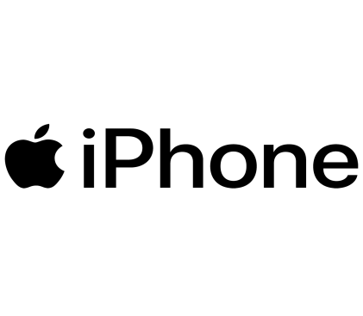

**Insights from iPhone Sales Performance Dashboard**

1. **Total Revenue**: ₹3 Billion, indicating strong sales performance.
2. **Average Star Rating**: 4.7, showing high customer satisfaction.
3. **Average Sale Price**: ₹80,074, suggesting a premium market positioning.
4. **Highest & Lowest Price Products**:
   * **Highest Price**: ₹1,40,900
   * **Lowest Price**: ₹29,999
5. **Discounted vs. Non-Discounted Products**:
   * 48 products are discounted.
   * 62 products are sold at full price, indicating a balanced pricing strategy.
6. **Product Performance**:
   * The Apple iPhone SE (White, 256GB) is one of the best-selling models.
   * The Apple iPhone SE (Red, 128GB) has moderate sales.
7. **Sales Price Distribution**:
   * The majority of sales occur in the ₹30,000 - ₹50,000 range.
   * Premium-priced models above ₹1,00,000 are fewer in number.
8. **Market Trends**:
   * Higher storage models (128GB and 256GB) are more popular.
   * Black and White color variants dominate sales.

**Conclusion**

* The iPhone market is premium-focused, with an **average sale price of ₹80,074**.
* **Discounting strategy is balanced**, ensuring both profit margins and customer appeal.
* **Customer satisfaction is high** with an average rating of **4.7 stars**.
* **Mid-range iPhones** (₹30,000 - ₹50,000) are the **most preferred segment**.
* **Storage capacity and color options** play a significant role in influencing buyer choices.